

SEND Information Report for Parents
2025-2026

Special Educational Needs (SEN) Information Report 2025–2026
Welcome from the SEND and Inclusion Team. This report explains how The Pavilion Study Centre identifies, supports, and monitors pupils with special educational needs and disabilities (SEND). At The Pavilion – Barnet’s Pupil Referral Unit (PRU), we provide education and support for children who are currently unable to attend mainstream school. This may be due to exclusion, challenges in managing within a large school setting, or because they have complex additional needs.
Our purpose is to help every child re-engage with learning, develop confidence, and build the skills they need to thrive. Children with Special Educational Needs and Disabilities (SEND) are statistically more likely to experience school exclusion. This can happen for many reasons: late or missed identification of needs, difficulties with communication or social interaction, anxiety, sensory needs, or behaviour that communicates distress. National data shows that pupils with SEND are around five times more likely to be permanently excluded than their peers.
At The Pavilion approximately 25% of our pupils meet the criteria for SEND.
Area of Need Examples of Conditions or Difficulties
- Communication and Interaction: Autism Spectrum Disorder (ASD); Speech and Language Difficulties
- Cognition and Learning: Specific Learning Difficulties such as Dyslexia, Dyspraxia, Dyscalculia; Moderate Learning Difficulties
-Social, Emotional and Mental Health (SEMH): Attention Deficit Hyperactivity Disorder (ADHD); attention deficit disorder (ADD); emotional regulation or anxiety-related difficulties
We believe that behaviour is a form of communication. Our aim is to identify each child’s needs early, provide the right support, and make sure every learner feels safe, valued, and successful.

1. Types of SEN We Support
We support pupils with a wide range of needs, including:
• Communication and interaction difficulties
• Cognition and learning challenges
• Social, emotional, and mental health needs
• Physical or sensory needs
• Complex and overlapping needs
2. Our SEN Team and Staff Training
Our Special Educational Needs Co-ordinator (SENCO) is Sasha Sappleton-Stone, an experienced SEND leader with over 15 years of expertise, including work as a Teacher and a Deputy SENDCO. She leads a highly skilled Inclusion Team that includes Teaching assistants and works really closely with the school’s link EPs. All staff are trained and supported to meet the diverse needs of our pupils.
Training includes:
• Trauma-informed practice and approaches
• Autism and ADHD awareness
• De-escalation strategies (Team Teach)
• Understanding cognition, learning, and attachment
• Communication-friendly approaches
• Restorative practice and solution-focused thinking
• Quality First Teaching and differentiation strategies
We also work closely with external professionals, including Early Help Practitioners, Speech and Language Therapists, CAMHS, Occupational Therapists, School Nurses, and Social Care.
3. If You Think Your Child Has SEN
We also work closely with external professionals, including Educational Psychologists, Speech and Language Therapists, CAMHS, Occupational Therapists, School Nurses, and Social Care.
4. How We Identify and Assess Needs
Every pupil joining The Pavilion Study Centre completes a baseline assessment during their first week. This includes:
• Lucid Exact (literacy and communication)-KS4
• Cognitive Ability Tests (CATs4)
• Progress Test Maths
• National Group Reading test
• Pupil Attitude to Self and School (PASS)
The SEND/Inclusion Team reviews result weekly and shares key information with staff to plan suitable support. If a pupil is not making expected progress, we follow the Graduated Approach:
1. Assess – Identify strengths and difficulties
2. Plan – Agree outcomes and support
3. Do – Put support in place
4. Review – Evaluate progress and adapt support
Where necessary, we involve external agencies or apply for an Education, Health and Care Plan (EHCP).
5. Monitoring Progress
We monitor your child’s progress regularly through:
• Classroom assessments and observation
• Six-weekly reviews of interventions
• Regular feedback from teachers, parents, and pupils
Parents can contact the SENCO at any time to discuss progress.
6. Working Together with Parents and Pupils
We value partnership with families. Parents and carers are invited to:
• Review meetings and progress discussions
• Planning meetings for interventions
• Transition and annual review meetings Pupils are encouraged to share their views through meetings, written reflections, or conversations with trusted adults.
7. Teaching and Learning Adaptations
At The Pavilion Study Centre, the Wave Model of Intervention provides a structured framework for how we identify and support pupils based on their level of need.
Wave 1 represents high-quality, inclusive teaching for all pupils — our universal offer. This includes differentiated teaching, communication-friendly classrooms, and clear routines that support every learner.
Wave 2 refers to targeted support for pupils who need additional help to make expected progress. This may involve small group interventions such as Literacy intervention, Numeracy intervention, or targeted support for social skills.
Wave 3 represents specialist and individualised support for pupils with more significant or persistent difficulties. This may include one-to-one teaching, specialist therapeutic input, or external agency involvement, such as Educational Psychology or CAMHS. Using this graduated approach ensures that support is carefully matched to each learner’s needs and remains both effective and evidence based. Teachers adapt lessons to meet the needs of all pupils. Adjustments may include:
• Simplified language and instructions
• Visual aids and structured timetables
• Pre-teaching of key vocabulary
• 1:1 or small group support
• Access to sensory or assistive technology
• Teaching strategies that are friendly for students with speech, language and communication difficulties (ELKLAN)
Targeted interventions include:
• Social Skills based on Talk about for Teenagers Programme
• That Spelling Thing- Literacy intervention
• Numeracy interventions

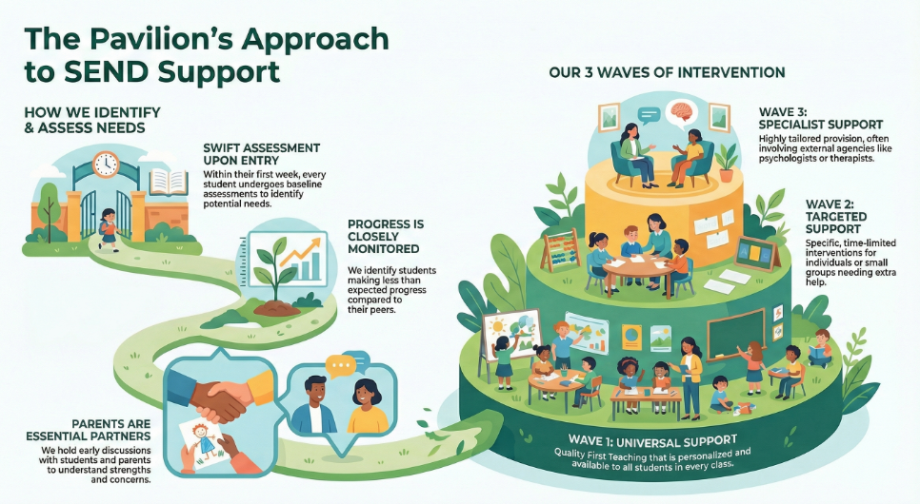

8. Evaluating SEN Provision
We regularly review the impact of support through:
• Data analysis and progress tracking
• Pupil and parent feedback
• SENCO and Governor monitoring
9. Supporting Emotional and Mental Health
Supporting emotional wellbeing is central to our work. We offer:
• One-to-one and group mentoring
• Referrals to CAMHS
• counselling
• CAMHS Art Therapy
• Trauma-informed and restorative practices
The Pavilion Study Centre holds a Trauma-Informed School Status.
10. Transitions and Next Steps
Transitions can be challenging, so we:
• Organise transition meetings with new schools
• Offer accompanied visits to next settings
• Provide personalised support and mentoring
• Share key information between SENCOs
11. Looked-After and Previously Looked-After Children
Our Designated Teacher is the Designated Safeguarding Lead to ensure the needs of looked-after children are met. Their Personal Education Plan (PEP) links closely to their SEN Support Plan or EHCP.
12. Accessibility and Inclusion
We make all reasonable adjustments to ensure accessibility, including:
• Adapted/ bespoke timetables
• Specialist equipment or resources
• Accessible facilities (including disabled toilets)
• Support for trips, clubs, and activities so all pupils can take part
13. Complaints
If you have concerns about SEN provision, please contact SENCO Sasha Sappleton-Stone in the first instance. If you are not satisfied, you can follow the school’s Complaints Policy.
14. Support for Families
You can find local SEND information and support via:
• National organisations: IPSEA, Special Needs Jungle, Family Action, and NSPCC
• Barnet Local Offer https://www.barnetlocaloffer.org.uk/
• Barnet SENDIASS https://www.barnet.gov.uk/children-and-families/barnet-send-information-advice-and-support-service-sendiass/about-sendiass

15. Monitoring and Review This SEN Information Report is reviewed annually by Sasha Sappleton-Stone (SENCO) and approved by the Governing Board.
Updates are made throughout the year if significant changes occur.
Reviewed: October 2025
Next Review Due: October 2026

We are proud to serve Barnet’s young people and their families, ensuring that every child— whatever their background or need—has the opportunity to learn, grow, and succeed.

