Capel Manor Visit

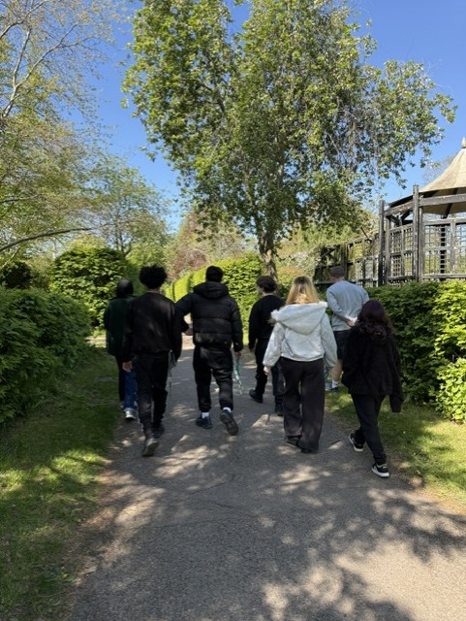
On a sunny 23rd April, a group of Year 9 and 10 pupils visited Capel Manor College in Enfield. We enjoyed a guided tour of all the different faculties. Starting with hard landscaping, those who were interested in Construction could see how building skills are used to create patios, paths, decks and outdoor kitchens.
We then moved on to the main horticulture tunnels and saw how students trained to become gardeners by learning about different plants.
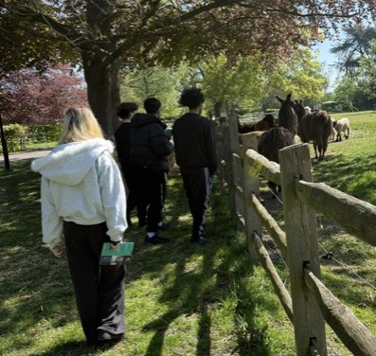
We did a short detour to the area where tree surgery is taught. We found out that, apart from learning about the different types of trees, students are taught to climb safely and use chainsaws. After a fun detour to the maze, where no one got lost, we moved on to the classrooms where floristry is taught, and the students were learning how to make wreaths. Finally, we visited the animal care department. This includes fields of Llamas, donkeys and ponies, as well as cages of meerkats and small mammals, before seeing a range of reptiles and snakes – behind glass! At Capel Manor, students can learn to become veterinary nurses, animal care assistants, dog groomers and zookeepers. The college is attached to a university where students can even train to become a vet.
On our way to the canteen, where we bought some drinks and snacks, we passed a collection of amazing gardens that the students had designed and planned and are open to the public.
The students were a credit to the Pavilion and were really engaged and enjoyed the trip.
Register now to attend an Open Day or Advice Evening!
Open Days - Capel Manor College

